**Project Final Report**

**Project # 10.D**

|  |  |
| --- | --- |
| **Project Name** | Write a program to find the house edge for Blackjack using the basic strategy and single deck. |
| **Description** | Our method for computing the House Edge will be to create a Monte-Carlo experiment in which we run multiple trials of a Blackjack game having the player utilize the basic strategy. From these multiple trials, we extract the win/lose probabilities for both Dealer and Player and from that are able to compute the House Edge. |
| **Language used** | Python |
| **Professor** | Jason Gao |
| **Group Members** | Eren Sulutas - 101101873  Nabeel Warsalee - 101103167  Cailyn Edwards - 100956026  Jingyi Wang - 101082676 |
| **Date** | April.23.2021 |

**Project Assumptions**

* Single deck
* Dealer stands on any 17 (including soft 17)
* No hole card: dealer does not draw nor consult their second card until after the player's final decision
* Split up to four hands
* Double down on any two initial cards, except for split Aces
* Split Aces may not hit (stand after drawing second card)
* No Blackjack after receiving a 10-value card after splitting Aces
* Player can only double/split on the first move, or the first move of a hand created by a split
* Surrender not permitted

**Goals**

Output the house edge with respect to Basic Strategy we use based on great quantities of (Monte-Carlo) simulations.

**Basic Strategy**

Each blackjack game has a *basic strategy*, which prescribes the optimal method of playing any hand against any dealer upcard so that the long-term [house advantage](https://en.wikipedia.org/wiki/House_advantage" \o "House advantage) (the expected loss of the player) is minimized. A standard basic strategy chart can only provide with the strategy for one set of rules, such as dealer hits on Soft 17.

*Composition-dependent :*

Optimal strategy based on the composition of cards in a player’s hand and the dealer’s upcard.

Basic strategy is based upon a player's point total and the dealer's visible card. Players may be able to improve on this decision by considering the precise composition of their hand, not just the point total. For example, players should ordinarily stand when holding 12 against a dealer 4. However, in a single deck game, players should hit if their 12 consists of a 10 and a 2. The presence of a 10 in the player's hand has two consequences:

* It makes the player's 12 a worse hand to stand on (since the only way to avoid losing is for the dealer to go bust, which is less likely if there are fewer 10s left in the shoe).
* It makes hitting safer, since the only way of going bust is to draw a 10, and this is less likely with a 10 already in the hand.

However, even when basic and composition-dependent strategies lead to different actions, the difference in expected reward is small, and it becomes even smaller with more decks. Using a composition-dependent strategy rather than basic strategy in a single deck game reduces the house edge by 4 in 10,000, which falls to 3 in 100,000 for a six-deck game

*Total-dependent : ( way we used to approach )*

Optimal strategy based on the total (hard or soft) in a player’s hand and the dealer’s upcard. Hence the player does not distinguish among (10,6), (9,7), and (2,4,5,5).

Most blackjack basic strategy charts are said to be "total dependent." That means the total of the player's cards is considered, but not the specific composition. Total dependent basic strategy also considers whether the hand is soft or hard, and whether doubling, splitting, or surrender is possible.

**Basic Strategy Specifications (total-dependent)**

There are two slightly different strategies depending on whether Dealer stand or hit on Soft 17 for total-dependent basic strategy.

In our case, we assume Dealer stands on Soft 17, chart shows below:

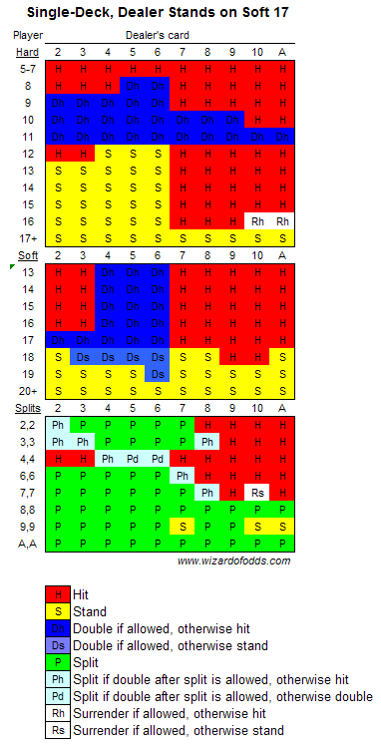

Also, the other case is Dealer hits on Soft 17:

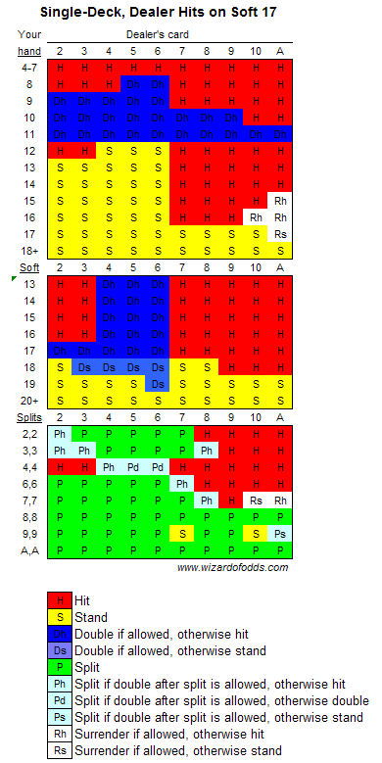

Other basic strategy rules:

* Never take insurance or "even money." The house edge on insurance is 5.9%, based on one deck.
* If there is no row for splitting (fives and tens), then look up your hand as a hard total (10 or 20).
* If you can't split because of a limit on re-splitting, then look up your hand as a hard total, except aces. In the extremely unlikely event you have a pair of aces you can't re-split and drawing to split aces is allowed, then double against a 5 or 6, otherwise hit.

**Trials Result Conclusion**

(to be filled)

**Computing the House Edge**

(to be filled)

**Annotated Bibliography**

### [Single-Deck Blackjack Strategy - Wizard of Odds,August.13.2019](https://wizardofodds.com/games/blackjack/strategy/1-deck/)

<https://wizardofodds.com/games/blackjack/strategy/1-deck/>

### [Total Dependent vs. Composition Dependent Basic](https://wizardofodds.com/games/blackjack/composition-dependent-benefit/)

<https://wizardofodds.com/games/blackjack/composition-dependent-benefit/>

### [Blackjack - Wikipedia](https://en.wikipedia.org/wiki/Blackjack)

<https://en.wikipedia.org/wiki/Blackjack>

### [Blackjack Basic Strategy Engine - BlackjackInfo.com](https://www.blackjackinfo.com/blackjack-basic-strategy-engine/)

<https://www.blackjackinfo.com/blackjack-basic-strategy-engine/?numdecks=1&soft17=s17&dbl=all&das=yes&surr=ns&peek=yes>